# **Debbie Valek Video Transcript**

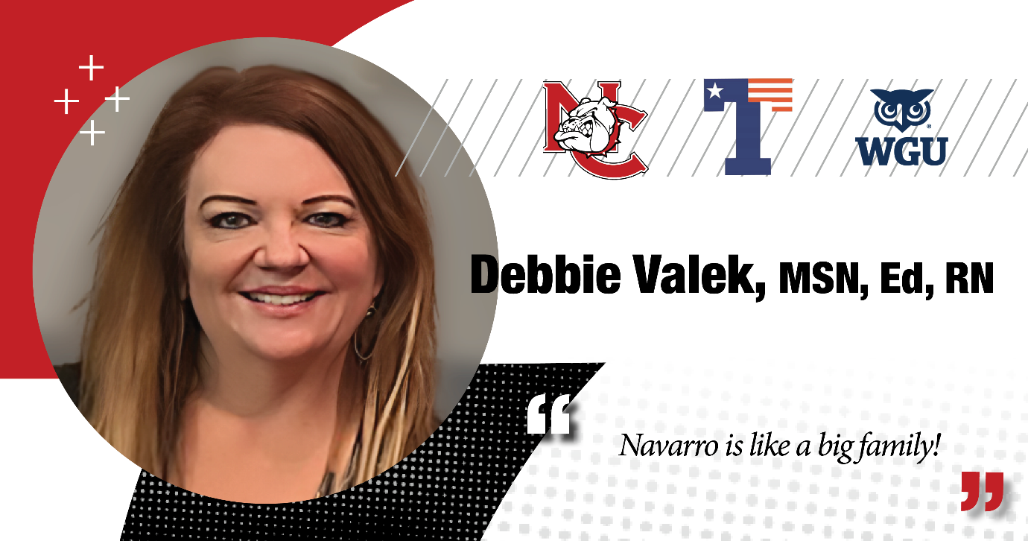

**Debbie Valek**: My name is Debbie Valek, and I'm the program director here at Navarro College. I've worked here about 20 years now. Before that, I was a student here at Navarro College.

I started here in about 1985. Before that, I was a teenage mom. I actually dropped out of school. A lot of people don't know that about me, but I actually dropped out of school in the 10th grade.

I was about two weeks into my 10th grade and I experienced a teenage pregnancy. I really didn't know what to do, so I decided I was just going to drop out of school. I had no confidence at the time, but I decided, you know, I guess I'll just stay home and just be a mom.

But I didn't want that. I wanted more for myself than that. I came here to Texas. We had lived out of state, and I decided to check out Navarro College. I came here and there was a professor here by the name of Dr. Richard Miller. I had zero confidence at the time. He sort of just took me under his wing and he gave me so much confidence. He helped me so much and I owe so much gratitude to him.

I wish I really knew where he was right now I don't even know. But he gave me the confidence I needed and helped me really believe in myself that I could do what I needed to do. And I took the classes I needed to take and he actually even offered me one-on-one counseling and helped me believe in what I needed to do, and I could do it.

So, I took the classes I needed, I took the prerequisites, I took the GED, I needed to take, and I passed it.

I took the classes, I went to nursing school, I got accepted and went to nursing school. I went through the program, and I passed with flying colors.

I became an RN and I worked through that. And since that time, I persevered, and I have finished my bachelor's degree, and I even went forward, and I received a Master's Degree in Science of Nursing and in Education.

So, if I can do it, anybody can do it.