# **Tim Moody Video Transcript**

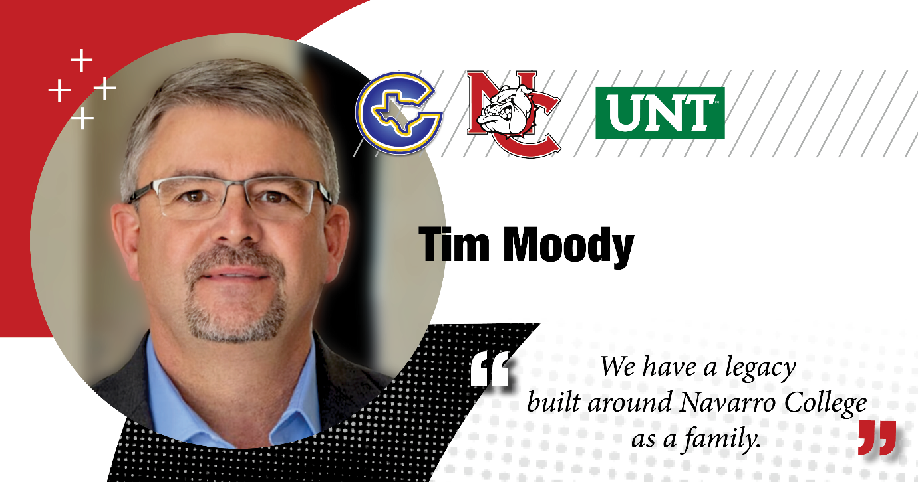

**Tim Moody:** I'm a graduate of Corsicana High School, came to Navarro College to play baseball here at Navarro and I did in 1987.

I graduated from Navarro College in 1988, went on to what was then North Texas State University, which is now UNT play baseball there and ended up program disbanded, and I went to work, and I went to work for the Texas Department of Transportation.

I spent 28 years there as a materials inspector, materials manager, building highways, bridge, road maintenance. So while working at Texas Department Transportation in Ellis County as materials manager, I was responsible for overseeing construction materials, approving those materials, putting the designs together for concrete paving of Interstate 45 as well as IH 35 E Navarro College really helped me as a young man straight out of high school.

Hometown kid here in Corsicana really was eye opening and began to help me grow up and understanding not just studies but relationships, relationships with instructors.

My family really inspires me. I have a legacy here at Navarro College with my dad graduating from Navarro College.

I have two daughters, one's a registered nurse, one is a schoolteacher. They both graduated from Navarro College. My wife currently works at Navarro College. So we wake up one day and we realize we have a legacy built around Navarro College as a family, and I so appreciate that.